Asymmetric DCC correlation: USDCHF and USDCAD
Method 10 / GARCH(1,1) + Cappiello-Engle-Sheppard ADCC / Alpari D1 full available history

Study setup
Logical pair: USDCHF , USDCAD
Broker symbols: USDCHF_i , USDCAD_i
Snapshot: 2026-11-03_majors_alpari_D1
Timeframe: D1
Matched return window: 1999-01-05 to 2026-11-02 (UTC bar dates)
Matched return count n: 7188
Dropped unfinished last bar dated 2026-11-03 UTC after a tick-volume check against the prior complete day.
USDCHF GARCH(1,1): mu=-0.000342, omega=0.003468, alpha=0.040954, beta=0.956741
USDCAD GARCH(1,1): mu=-0.000009, omega=0.001259, alpha=0.043622, beta=0.951229
ADCC: a=0.007073, b=0.968277, g=0.047300, a+b+g/2=0.999000
Nested DCC (g=0): a=0.020250, b=0.977974
Negative shock: n = min(z, 0) in broker quote direction (not inverted)
Burn-in ignored in path summaries and chart: first 60 updates
Complete matched rows (Excel): USDCHF-USDCAD_ADCC_D1.xlsx
Complete matched rows (HTML table): USDCHF-USDCAD_ADCC_D1_data.html

Method carried forward
Asymmetric DCC extends Engle DCC with an extra term on joint negative standardised shocks. Each matched daily log return of close, ln(close_t / close_t-1), is first filtered by a constant-mean GARCH(1,1). Then z = residual / sigma and n = min(z, 0). The Cappiello-Engle-Sheppard recursion uses A = (1-a-b) Q_bar - g N_bar with N_bar = mean(n n'). Quotes are not inverted, so a negative shock is a negative log return in the broker quote. Nested symmetric DCC (g = 0) is fit on the same z path for comparison. Constraints: a,b,g >= 0 and a + b + g/2 < 1. Path summaries ignore the first 60 updates. The headline is latest ADCC rho. Pearson r is a side check only. This is not a cause, lead, or trading signal.

Results
Latest ADCC rho: 0.523387
Latest nested DCC rho: 0.581011
Post-burn-in ADCC path (n=7128): mean=0.343939, median=0.349980, min=-0.130791, max=0.782990, std=0.178818
Share of post-burn-in days with |rho| >= 0.4: 39.46%; |rho| >= 0.7: 1.37%
Same-sample Pearson r: 0.304665
ADCC minus r: 0.218722
ADCC minus nested DCC: -0.057623

Conclusion
Over 7188 matched daily log-return rows for USDCHF and USDCAD (broker quote directions unchanged), latest ADCC rho is 0.5234 (positive, moderate conditional linear link in this sample) with fitted a=0.0071, b=0.9683, g=0.0473. Nested symmetric DCC latest rho is 0.5810 (ADCC minus DCC = -0.0576). After a 60-day burn-in, path mean is 0.3439 and std is 0.1788. Same-sample Pearson r is 0.3047 (ADCC minus r = 0.2187). This does not establish cause, lead-lag, or a lasting trading rule.

Charts
Daily closes

Daily log returns
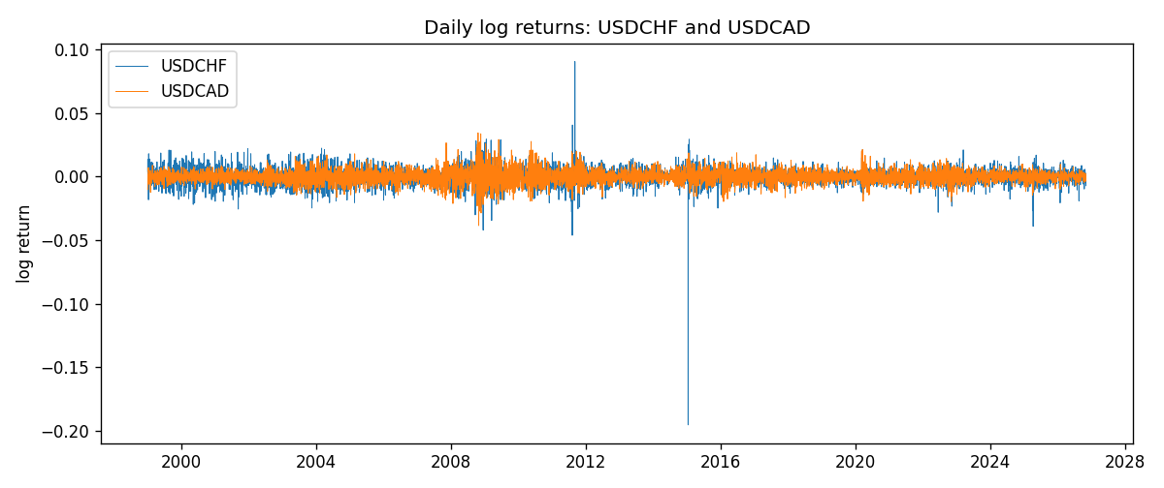
ADCC rho path with nested DCC and Pearson r
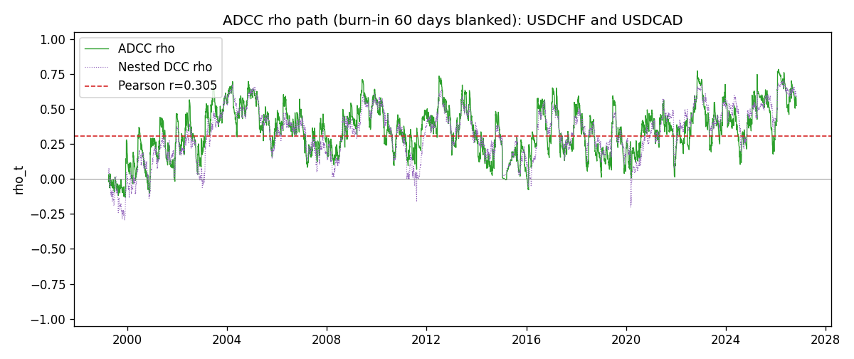

Data report
Every matched row that entered the ADCC recursion is stored in the sibling Excel workbook named USDCHF-USDCAD_ADCC_D1.xlsx. Embedding all rows as a Word table is impractical at this length; the Word file holds the column list, column summaries, and the first and last 15 matched rows.
Columns: time, USDCHF_open, USDCAD_open, USDCHF_high, USDCAD_high, USDCHF_low, USDCAD_low, USDCHF_close, USDCAD_close, USDCHF_tick_volume, USDCAD_tick_volume, USDCHF_spread, USDCAD_spread, USDCHF_real_volume, USDCAD_real_volume, USDCHF_log_return, USDCAD_log_return, USDCHF_sigma, USDCAD_sigma, USDCHF_z, USDCAD_z, USDCHF_n, USDCAD_n, q11, q22, q12, rho_adcc, rho_dcc
Column summaries (matched calculation rows)
column | count | mean | std | min | 25% | 50% | 75% | max
USDCHF_open | 7188 | 1.0975966 | 0.25229688 | 0.72022 | 0.9205375 | 0.989955 | 1.2378 | 1.8219
USDCAD_open | 7188 | 1.2667824 | 0.16892678 | 0.9168 | 1.1183975 | 1.298465 | 1.3720475 | 1.6183
USDCHF_high | 7188 | 1.1028875 | 0.2540352 | 0.73305 | 0.924845 | 0.993545 | 1.242375 | 1.8313
USDCAD_high | 7188 | 1.2716804 | 0.16888565 | 0.9336 | 1.12285 | 1.30387 | 1.37646 | 1.619
USDCHF_low | 7188 | 1.0924772 | 0.25071604 | 0.08565 | 0.91725 | 0.9863 | 1.23155 | 1.8121
USDCAD_low | 7188 | 1.2622243 | 0.16896256 | 0.9056 | 1.114065 | 1.293535 | 1.3677775 | 1.6102
USDCHF_close | 7188 | 1.0975873 | 0.25219296 | 0.72025 | 0.920805 | 0.98995 | 1.2379 | 1.8217
USDCAD_close | 7188 | 1.2667976 | 0.16890032 | 0.916 | 1.118075 | 1.29844 | 1.372365 | 1.6137
USDCHF_tick_volume | 7188 | 74305.244 | 113479.97 | 1 | 12787.25 | 40220 | 70419.75 | 858589
USDCAD_tick_volume | 7188 | 81017.898 | 147302.44 | 1 | 5560 | 40941.5 | 71627 | 1410818
USDCHF_spread | 7188 | 26.050501 | 24.7086 | 0 | 5 | 16 | 50 | 100
USDCAD_spread | 7188 | 23.4399 | 18.261108 | 0 | 9 | 17 | 40 | 60
USDCHF_real_volume | 7188 | 2.3284369e+10 | 8.9116261e+10 | 0 | 0 | 0 | 0 | 1.9331921e+12
USDCAD_real_volume | 7188 | 1.8376704e+10 | 9.6688094e+10 | 0 | 0 | 0 | 0 | 2.5751613e+12
USDCHF_log_return | 7188 | -7.133e-05 | 0.00659527 | -0.19545699 | -0.0033544 | 8.077e-05 | 0.00332477 | 0.09051364
USDCAD_log_return | 7188 | -1.556e-05 | 0.00514382 | -0.03859748 | -0.00283746 | 4.44e-05 | 0.00272629 | 0.03436319
USDCHF_sigma | 7188 | 0.00655211 | 0.00254561 | 0.00362103 | 0.00508761 | 0.00611038 | 0.00731757 | 0.03987635
USDCAD_sigma | 7188 | 0.00479489 | 0.00181328 | 0.0025109 | 0.00364892 | 0.00435952 | 0.00535062 | 0.01852279
USDCHF_z | 7188 | 0.03923134 | 0.99910573 | -34.46962 | -0.482871 | 0.07030133 | 0.59718743 | 6.7485143
USDCAD_z | 7188 | 0.00164982 | 1.0000914 | -4.0688676 | -0.62843993 | 0.00913085 | 0.61324519 | 6.4151667
USDCHF_n | 7188 | -0.33071168 | 0.6792704 | -34.46962 | -0.482871 | 0 | 0 | 0
USDCAD_n | 7188 | -0.38692658 | 0.58810051 | -4.0688676 | -0.62843993 | 0 | 0 | 0
q11 | 7188 | 1.0012888 | 3.0060406 | 0.18043557 | 0.53533053 | 0.69164849 | 0.87436699 | 64.965156
q22 | 7188 | 1.0006698 | 0.25096974 | 0.44662671 | 0.82471677 | 0.96605971 | 1.127417 | 2.1888907
q12 | 7188 | 0.29926714 | 0.20114114 | -0.11408614 | 0.17059925 | 0.26903633 | 0.40053948 | 1.6998593
rho_adcc | 7188 | 0.34181261 | 0.17968778 | -0.13079147 | 0.2176466 | 0.34863048 | 0.4701882 | 0.78299035
rho_dcc | 7188 | 0.32226963 | 0.18711839 | -0.29581854 | 0.19429077 | 0.34572964 | 0.45933978 | 0.70535526
First 15 matched rows (selected columns)
time | USDCHF_log_return | USDCAD_log_return | USDCHF_z | USDCAD_z | USDCHF_n | USDCAD_n | q11 | q22 | q12 | rho_adcc | rho_dcc
1999-01-05 | 0.0039424743 | -0.010131666 | 0.51082839 | -2.2395101 | 0 | -2.2395101 | 1 | 1 | 0.29958445 | 0.29958445 | 0.29958445
1999-01-06 | 0.013605652 | -0.0003306769 | 1.6865379 | -0.065593976 | 0 | -0.065593976 | 0.96777758 | 1.2421932 | 0.27879889 | 0.25427794 | 0.26195527
1999-01-07 | -0.0093883841 | 0.0015202092 | -1.0534997 | 0.31897492 | -1.0534997 | 0 | 0.95485087 | 1.2042322 | 0.26598207 | 0.24804442 | 0.25237257
1999-01-08 | 0.011040268 | -0.0020495197 | 1.3208635 | -0.43407902 | 0 | -0.43407902 | 0.98256201 | 1.1679612 | 0.25197743 | 0.23521632 | 0.24282946
1999-01-11 | 0.0052963193 | -0.0035137769 | 0.64378423 | -0.75893447 | 0 | -0.75893447 | 0.96138762 | 1.1423664 | 0.23673845 | 0.22590031 | 0.22705258
1999-01-12 | -0.0098275602 | 0.0066194721 | -1.0951798 | 1.4483406 | -1.0951798 | 0 | 0.93147595 | 1.1386564 | 0.22258249 | 0.2161269 | 0.21524197
1999-01-13 | -0.018259701 | 0.0045420214 | -2.0579292 | 0.97103648 | -2.0579292 | 0 | 0.96479815 | 1.1185836 | 0.20111198 | 0.19359115 | 0.17731657
1999-01-14 | -0.0024256692 | 0.0069376546 | -0.22470137 | 1.4835868 | -0.22470137 | 0 | 1.1621222 | 1.0909794 | 0.17740748 | 0.15755702 | 0.1308051
1999-01-15 | 0.01794228 | -0.0056905671 | 2.0089821 | -1.1824307 | 0 | -1.1824307 | 1.1256564 | 1.0731499 | 0.16623166 | 0.15124486 | 0.12189993
1999-01-18 | -0.0031856384 | 0.00098344542 | -0.29446821 | 0.20477678 | -0.29446821 | 0 | 1.1161497 | 1.1163394 | 0.14096594 | 0.12628589 | 0.072322901
1999-01-19 | -7.2518946e-05 | 0.002748513 | 0.028371252 | 0.58113443 | 0 | 0 | 1.0831117 | 1.0824336 | 0.13287761 | 0.12271978 | 0.071477017
1999-01-20 | 0.0072259871 | -0.0059646885 | 0.81420447 | -1.2732889 | 0 | -1.2732889 | 1.0464126 | 1.0516956 | 0.12558902 | 0.11971681 | 0.07193653
1999-01-21 | -0.0038232689 | -0.0042823796 | -0.37688839 | -0.90121466 | -0.37688839 | -0.90121466 | 1.0155612 | 1.1076976 | 0.11108205 | 0.1047322 | 0.050931659
1999-01-22 | -0.0001445609 | 0.0025057712 | 0.021690087 | 0.53245235 | 0 | 0 | 0.98872285 | 1.1179308 | 0.1228366 | 0.11683771 | 0.057438681
1999-01-25 | 0.0024546976 | 0.00085579808 | 0.31406251 | 0.18600594 | 0 | 0 | 0.95501577 | 1.0856832 | 0.11583161 | 0.11375493 | 0.057921087
Last 15 matched rows (selected columns)
time | USDCHF_log_return | USDCAD_log_return | USDCHF_z | USDCAD_z | USDCHF_n | USDCAD_n | q11 | q22 | q12 | rho_adcc | rho_dcc
2026-10-13 | -0.0024955621 | -0.0046395653 | -0.45073644 | -1.6034253 | -0.45073644 | -1.6034253 | 0.52291057 | 0.69871957 | 0.30466054 | 0.5040238 | 0.60309038
2026-10-14 | 0.0029388325 | 0.0015184751 | 0.69332274 | 0.50937302 | 0 | 0 | 0.51502398 | 0.8175581 | 0.33110269 | 0.51025782 | 0.60067989
2026-10-15 | -0.0097855323 | -0.0036101503 | -2.0041302 | -1.2150737 | -2.0041302 | -1.2150737 | 0.49974098 | 0.79466926 | 0.3199071 | 0.50764275 | 0.60326898
2026-10-16 | -0.0036230826 | -0.0034322068 | -0.65312232 | -1.1381064 | -0.65312232 | -1.1381064 | 0.69993576 | 0.85094847 | 0.43897705 | 0.56880198 | 0.6208235
2026-10-19 | 0.0036351779 | -0.0018835331 | 0.79630521 | -0.61656447 | 0 | -0.61656447 | 0.69858066 | 0.89559432 | 0.46227835 | 0.58443957 | 0.62565098
2026-10-20 | -0.0026281224 | -0.0037066008 | -0.45863931 | -1.2276973 | -0.45863931 | -1.2276973 | 0.67855971 | 0.88906483 | 0.44095066 | 0.56771353 | 0.60445919
2026-10-21 | -0.00040027413 | -0.00084691787 | -0.011900234 | -0.27398037 | -0.011900234 | -0.27398037 | 0.66612617 | 0.94402621 | 0.4543884 | 0.57300309 | 0.60543029
2026-10-22 | -0.0048036381 | -0.0026307268 | -0.91782047 | -0.87141289 | -0.91782047 | -0.87141289 | 0.64265732 | 0.91937169 | 0.43696106 | 0.56846987 | 0.60427581
2026-10-23 | 0.005652514 | 2.85545e-05 | 1.229314 | 0.012539347 | 0 | 0 | 0.66572916 | 0.93270679 | 0.46339722 | 0.58807411 | 0.61161608
2026-10-26 | 0.0018407959 | 5.7106554e-05 | 0.44032231 | 0.022432446 | 0 | 0 | 0.6529544 | 0.90433093 | 0.44561584 | 0.5799032 | 0.59883833
2026-10-27 | 0.0026100526 | 0.0025379458 | 0.60194616 | 0.87773179 | 0 | 0 | 0.63126708 | 0.87685768 | 0.42835938 | 0.57575426 | 0.59683194
2026-10-28 | -0.0010142111 | -0.0038379274 | -0.13814883 | -1.3195561 | -0.13814883 | -1.3195561 | 0.61145929 | 0.85570176 | 0.41531763 | 0.57416323 | 0.60125784
2026-10-29 | -0.0048680164 | -0.00011436495 | -0.94286634 | -0.035525284 | -0.94286634 | -0.035525284 | 0.59075467 | 0.92444423 | 0.40886448 | 0.55326786 | 0.59221505
2026-10-30 | 0.00071594559 | -0.0010298736 | 0.21938306 | -0.35068175 | 0 | -0.35068175 | 0.61800699 | 0.89639799 | 0.3945253 | 0.5300633 | 0.58505776
2026-11-02 | -0.0071459744 | 0.00061519094 | -1.4305784 | 0.21762147 | -1.4305784 | 0 | 0.59639736 | 0.87585956 | 0.37827557 | 0.52338733 | 0.58101068

